Ethereum on Windows:

Step 1: open the geth console with required network id and port

geth --networkid 9603 --port 9603 --rpc --lightkdf --cache 16 --datadir "C:\xxxxx" console

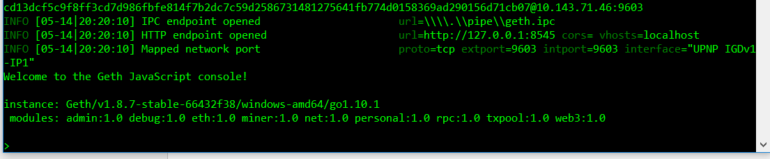

Once the console is started, create an account. This can be used in genesis block to assign the initial number of ether

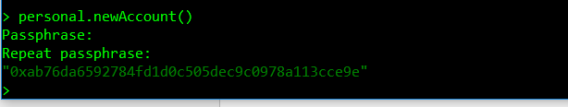

Exit the console

Take the account and give it in the genesis block to alloc the ether at the start

{"config": {

"chainId": 818781,

"homesteadBlock": 0,

"eip155Block": 0,

"eip158Block": 0

},

"difficulty": "20",

"gasLimit": "31415920000",

"alloc": {

"0xab76da6592784fd1d0c505dec9c0978a113cce9e": { "balance": "9000000000000000000000000000" }

}

}

Once the genesis block is ready, init the genesis json file.

Note: here you may face “database already contains an incompatible genesis block” issue. Remove the chaindata folder from your data dir and then re run the command

geth --datadir "C:\xxx" init "C:\ETH\configs\genesis.json"

Now start the console again as we have done in the starting

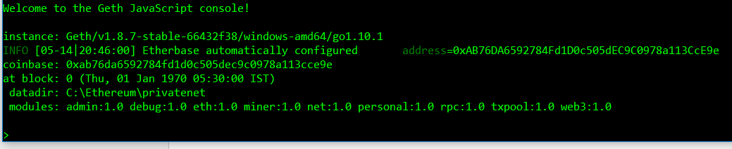

Check for the balance of the account you used in the genesis block



Use below command to check balance in different denominations

web3.fromWei(eth.getBalance(eth.coinbase), "ether")

now you can start mining using the command

miner.start(1)

if you are running the miner for the first time, the DAG will be created and then the mining starts

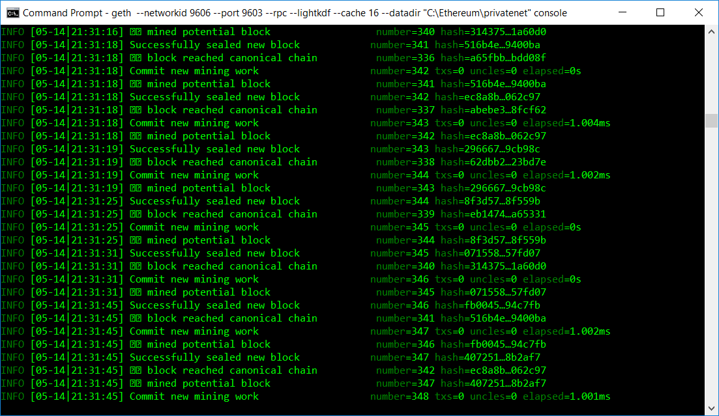

Open one more command prompt and give the below command to attach the geth console

geth attach ipc:\\.\pipe\geth.ipc

you can give miner.stop() in the first command prompt(where mining is happening) to stop the mining

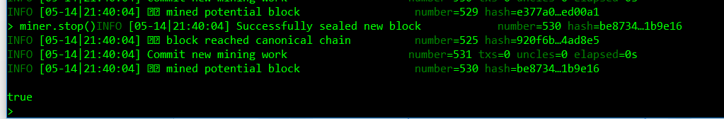

Connecting private net to remix

To connect to a remix ide, in windows, use the below command to start the geth console

geth --networkid 9603 --port 9603 --rpc --rpcport 9603 --rpcapi "db,net,web3,personal,eth" --rpccorsdomain "\*" --rpcaddr "192.168.0.6" --lightkdf --cache 16 --datadir "C:\Ethereum\privatenet" console

1. Select the Web3provider

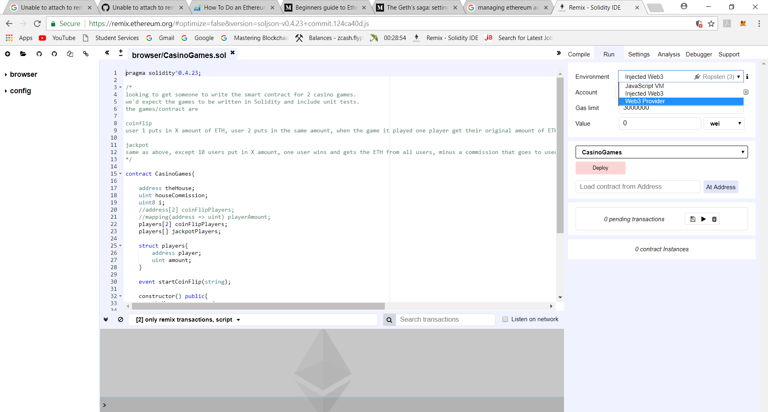

Click OK as you get below prompt

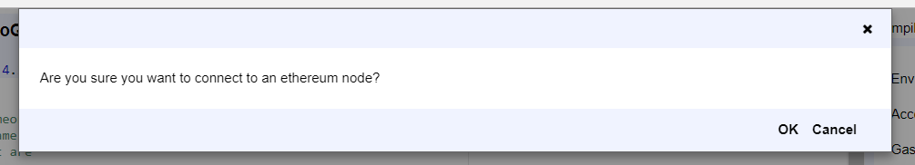

Here give your ip address followed by your port id

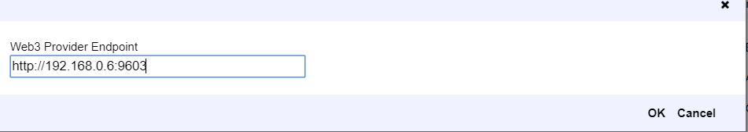

Once remix is connected to your privatenet enable the personal mode in settings

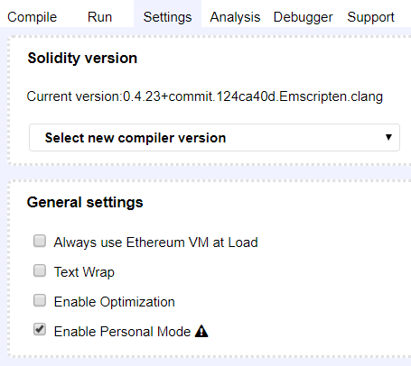

This will help you to create new accounts directly from remix.